- http://www.hawley.portal.rschooltoday.com/admin/build/module/jobposting/s/2477/2492/posts/move/5

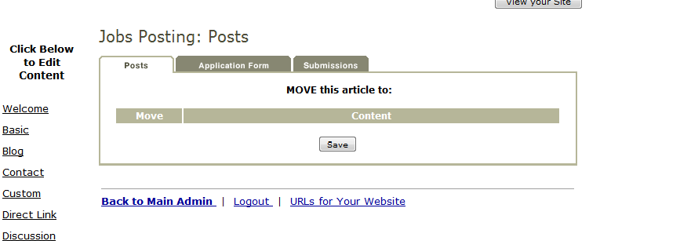

*tdak bisa menemukan move kemana?

- Hal yg sama ada di live test colo server : http://www.test.new.rschooltoday.com/admin/build/module/jobposting/s/2477/2488/posts/move/9
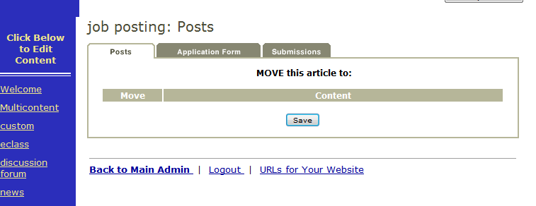
- Tapi tidak untuk yang di Of server : http://www.testingdepartment.portal.rschooltoday.com/admin/build/module/jobposting/s/2480/2498/posts/move/4
